CP2406 assignment1 work document

Seo JunMyeong

13470171

* **Problem specification:**
* What exactly is the problem?
  + - Firstly, this assignment requires a lot of condition to work this simulator. Thus, I have to be familiar with those conditions. Moreover, there are a lot of skills of coding is required. Such as menu bar, auto car driving and length of road. Thus, make sure I have to learn it.
* How will the program be used?
  + - Program will be used to run and simulator the program of road traffic.
* How will the program behave?
  + - Program will be used for design the road. User can edit the road and run it for test. Moreover, user can simulate the road situation.

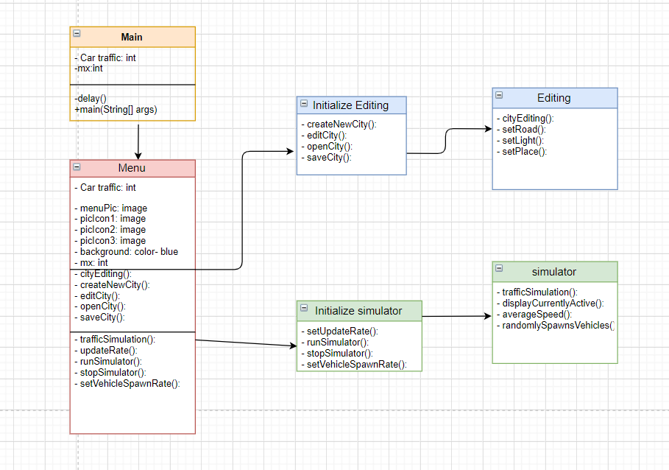

UML Question

1. What role(s) do objects of this class perform?
   * + Each class perform the menu of what user can use. For example, editing class, user can use edit traffic situation. Also, in simulation class, user can run the program that user edited and test it.
2. What member fields do objects of this class need? Should they be public or private?
   * + The road designer can use this program to design and edit the blue print.
     + This program should be private. Because the blue print should not be shared.
3. What methods do objects of this class need? Should they be public or private?
   * + There are several classes existed. In case of edit, it contains creating new city, edit city, open city and save city. Those things are used for editing city and edit road which is made by user. It helps user make it more creative and more finely. It should be private. Because user have to edit and create those by user’s idea and should not be controlled by others.
     + In case of simulation, it also contains set up rate and run simulation. This should be public. Because as other user run it and they can comment about this program.